- Enable SNS for CloudTrial to send alert on email.
Step 1: Login to AWSGoto SNSTopicsCreate TopicsEnter detailsCreate Topic.
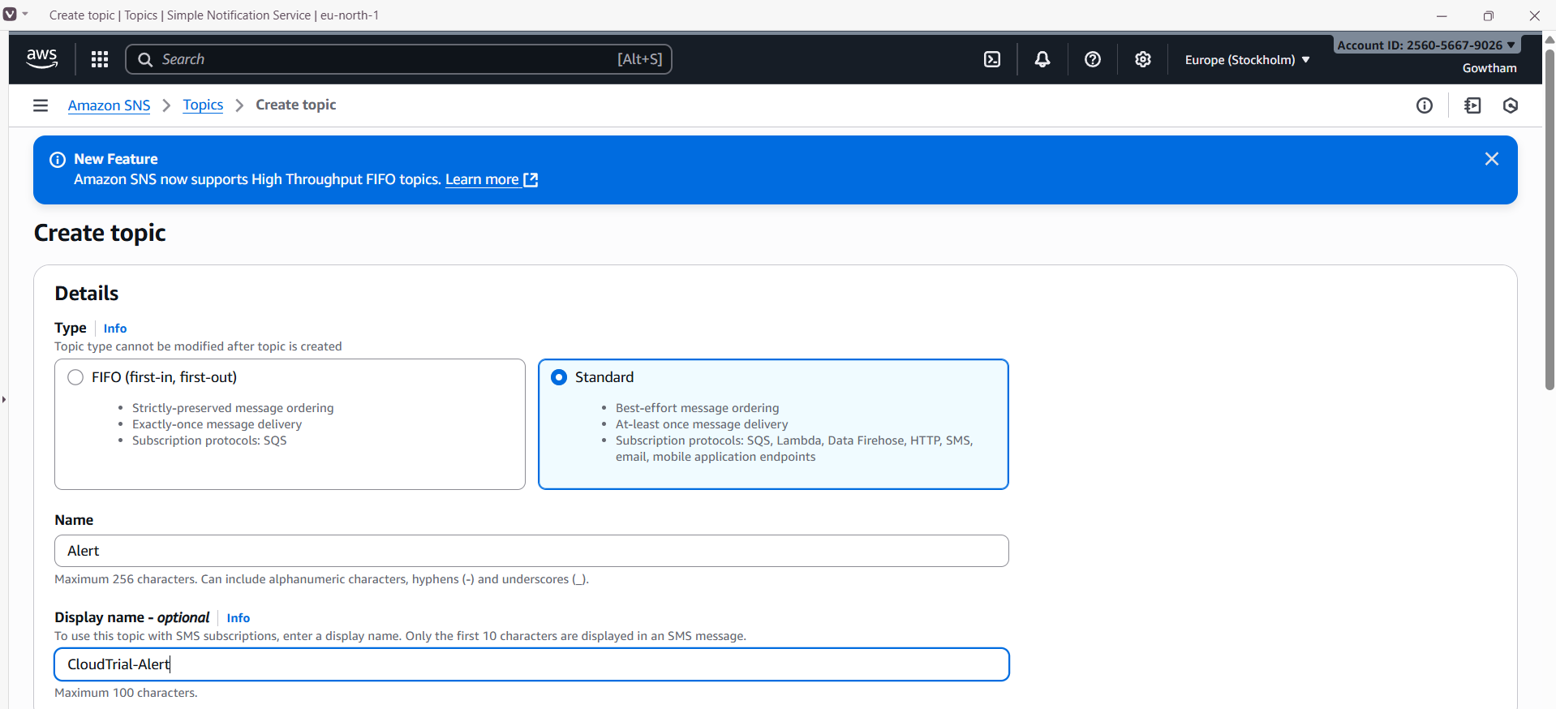
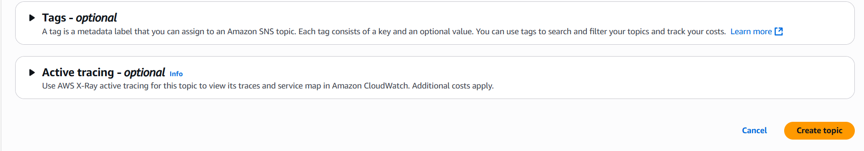
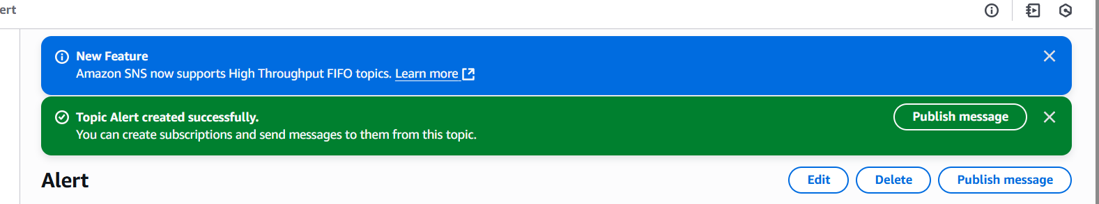
Step 2: Select create subsricptionEnter detailscreate subscriptionAccept the mail.
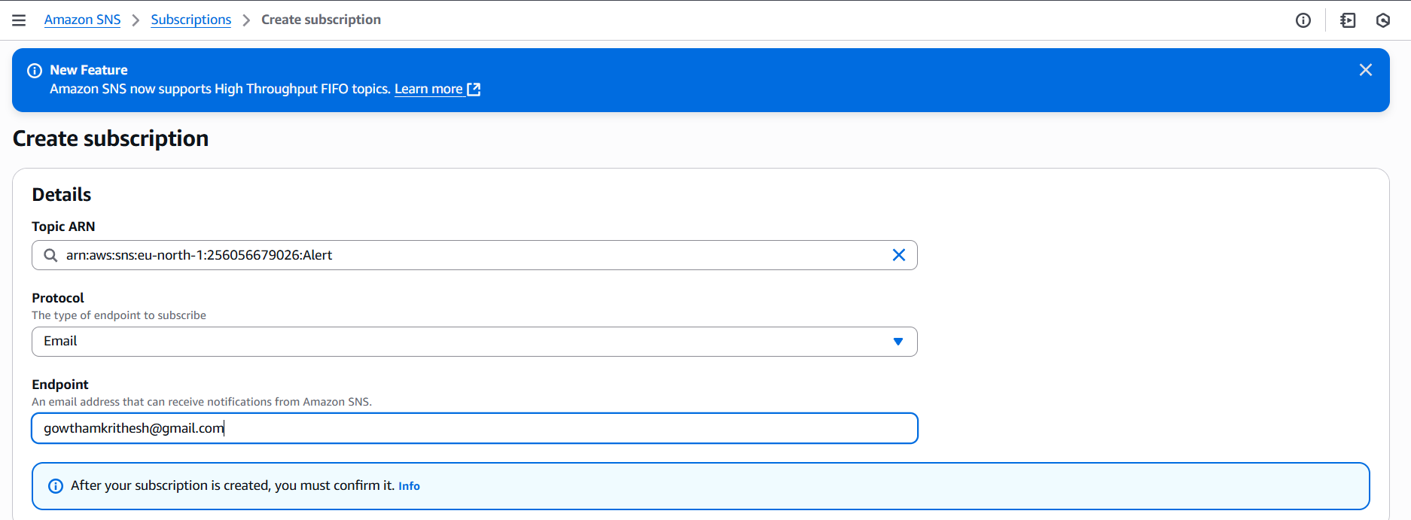

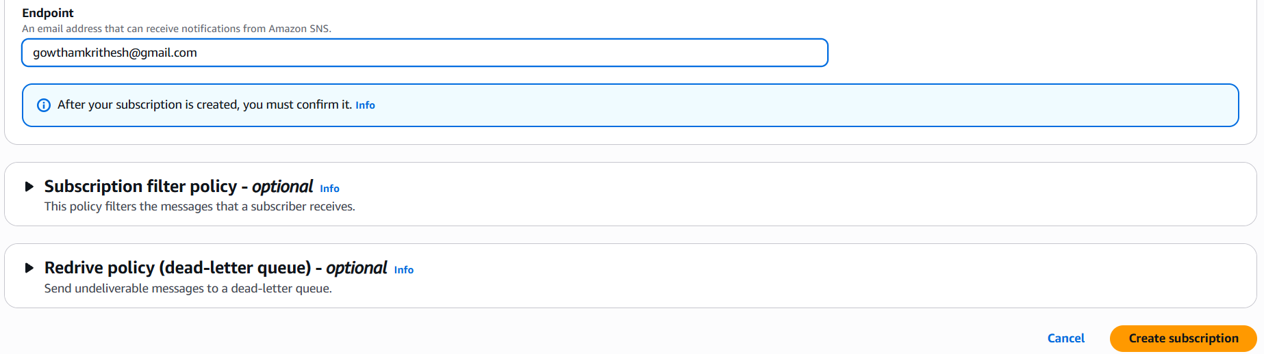
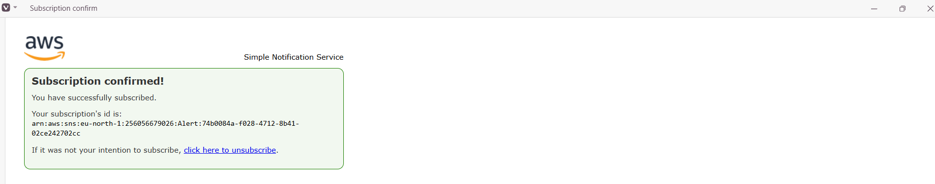
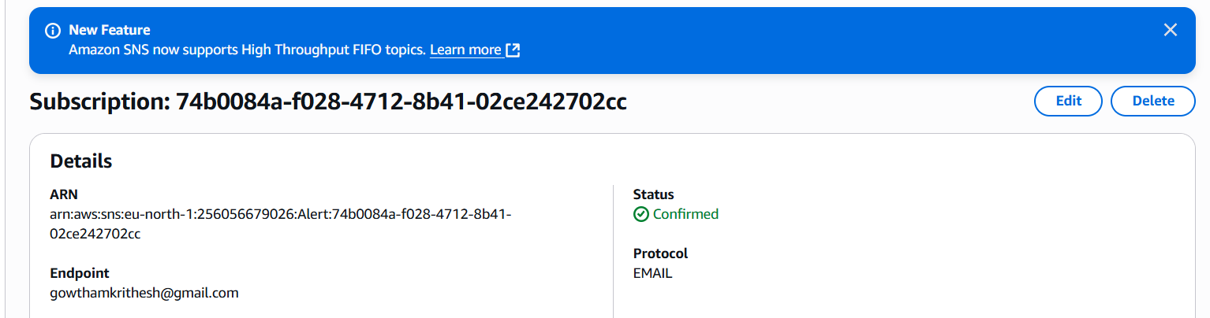

- Enable cloudtrail monitoring and store the events in s3 and cloudwatch log events.
Step 1:Goto CloudTrialcreate CloudTrialfull CloudTrialEnter detailsNext.
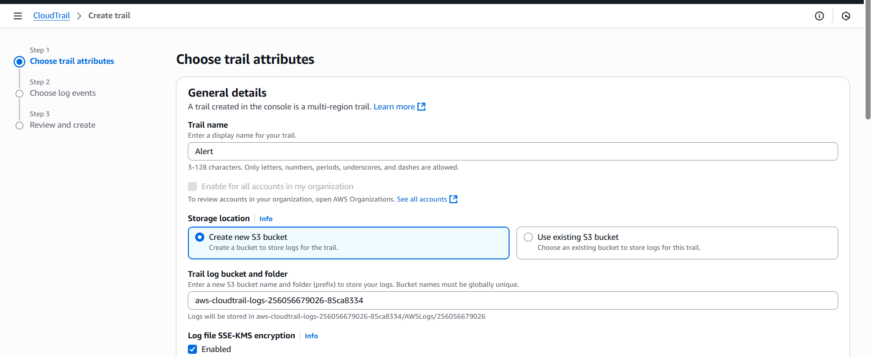
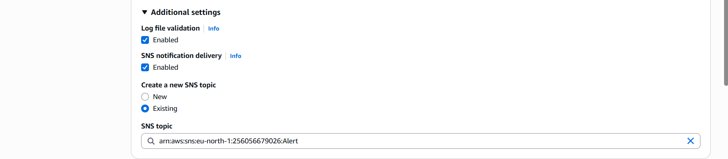
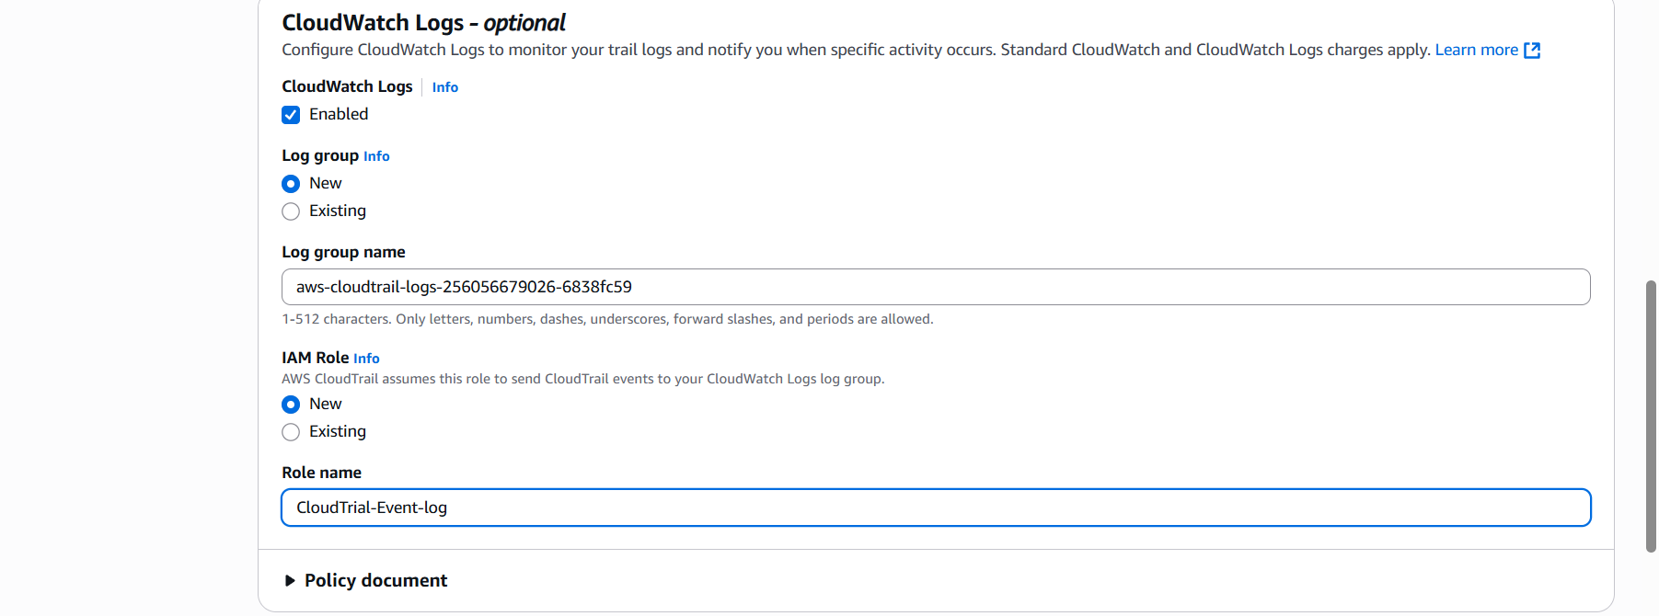
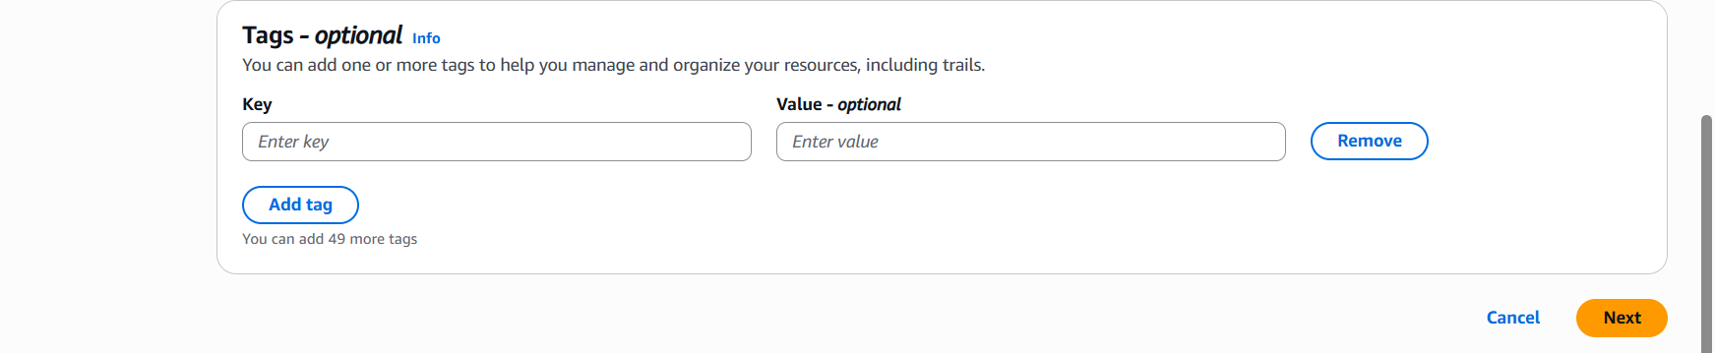
Step 2: Select the type of events you want to captureNextReview and click create trial.
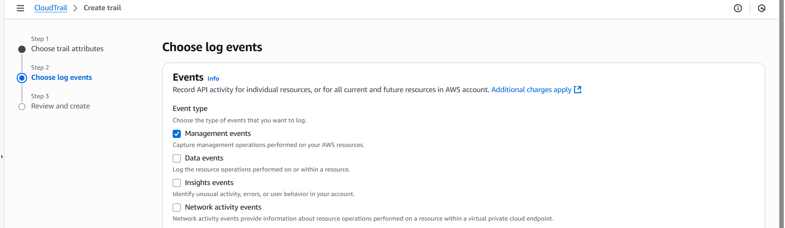
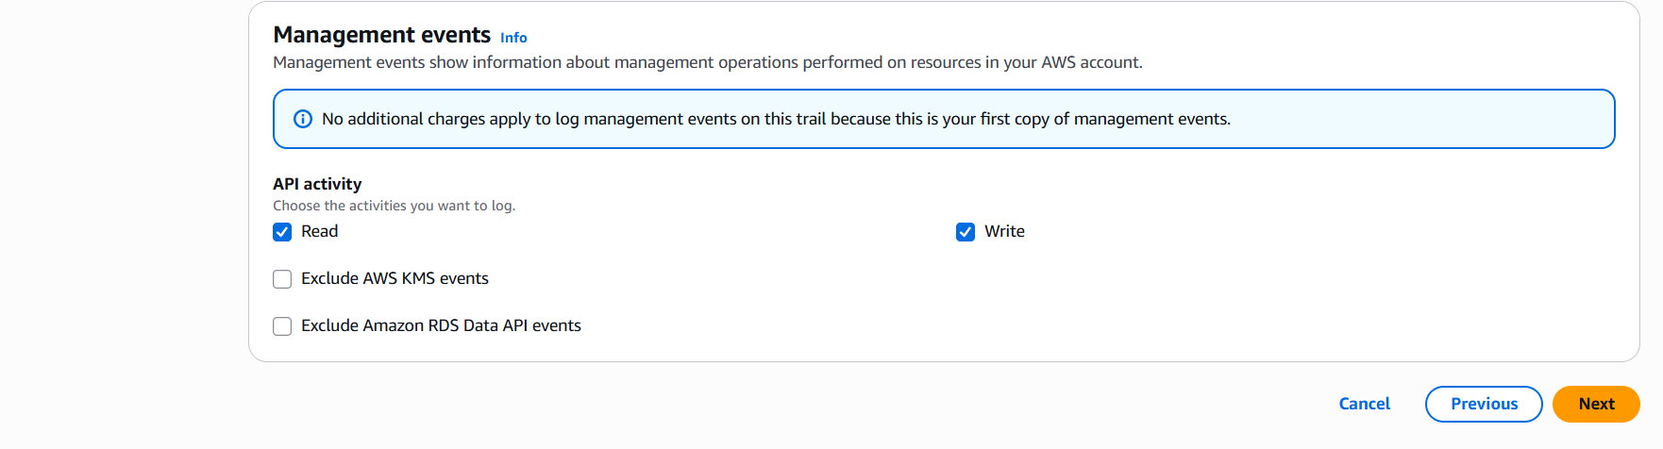
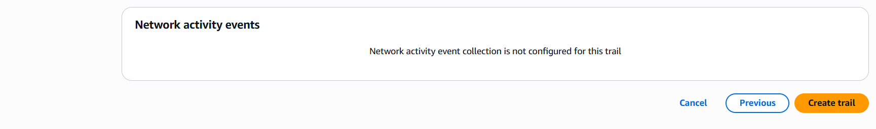

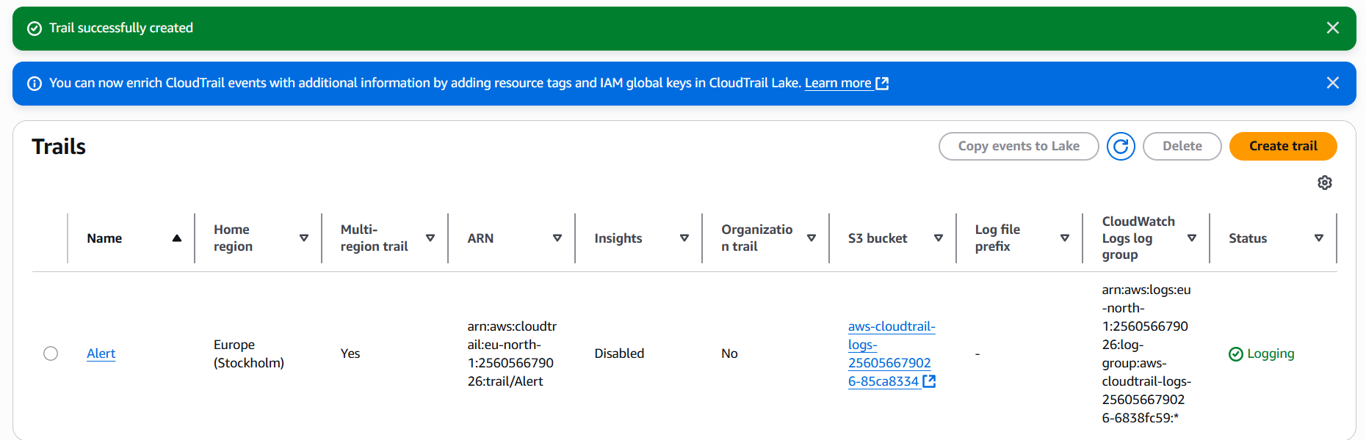

- Configure cloud watch monitoring and record the cpu utilization and other metrics of ec2.
Step 1: Launch an EC2 instance and Goto CloudwatchDashboardcreate DashboardAdd widgetsSelect EC2pre-instance metricsselect CPU utilization of your instancecreate.
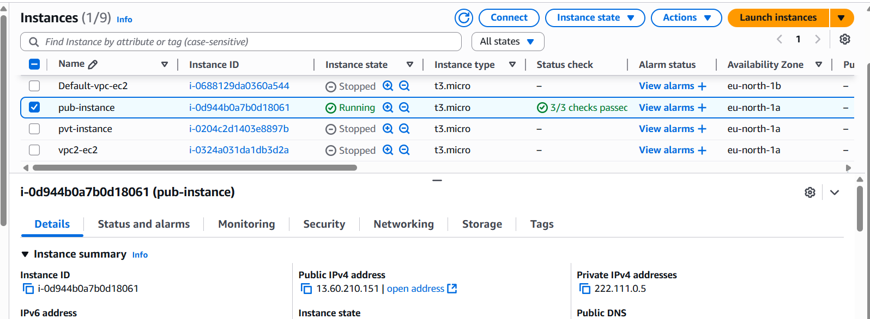
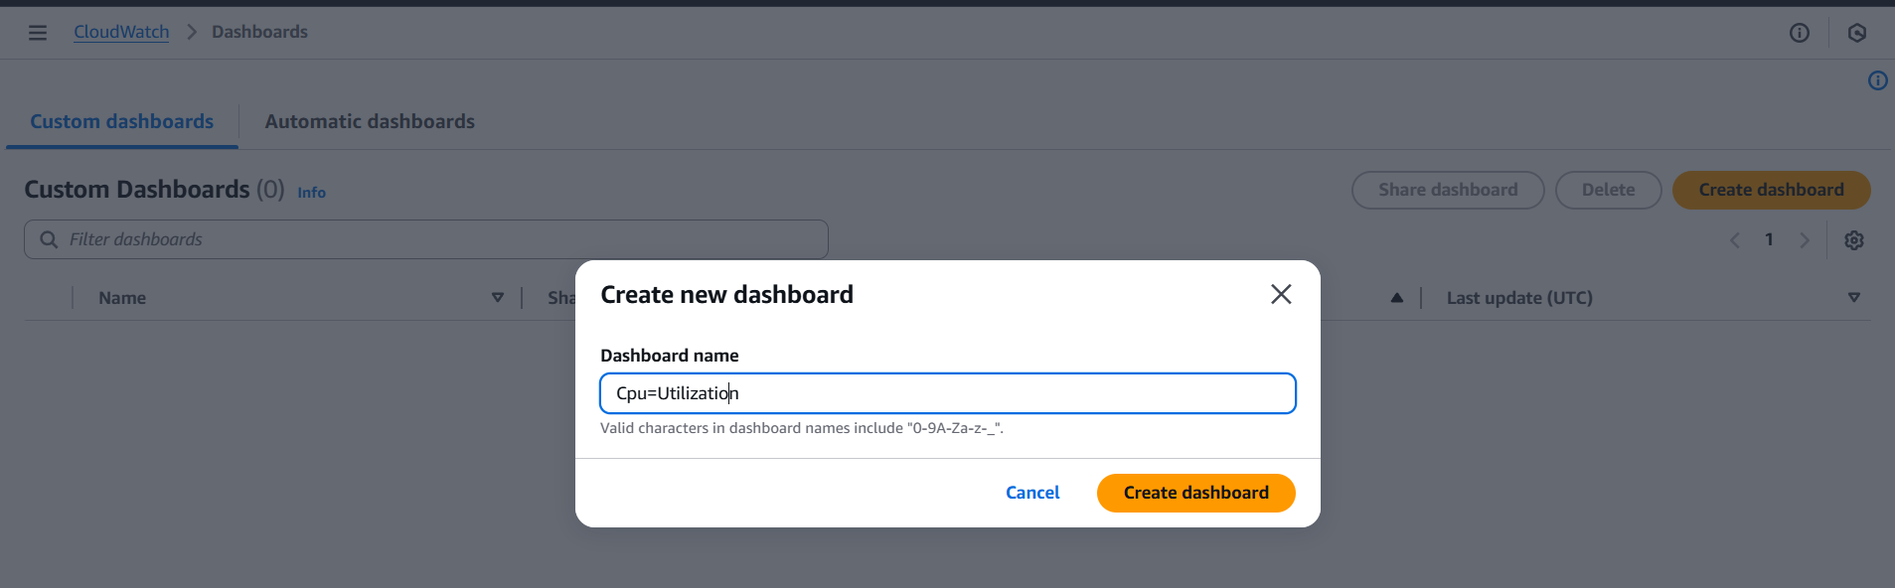
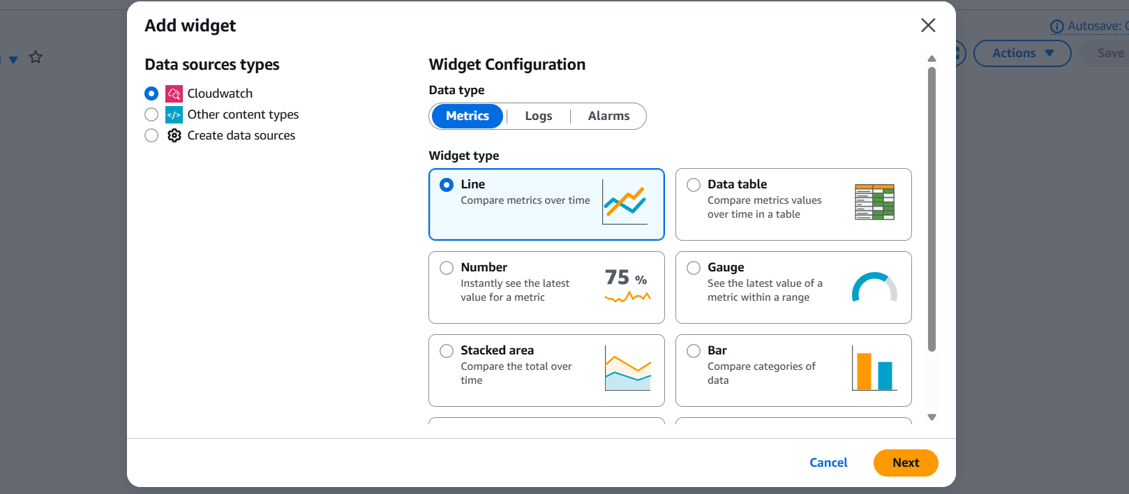
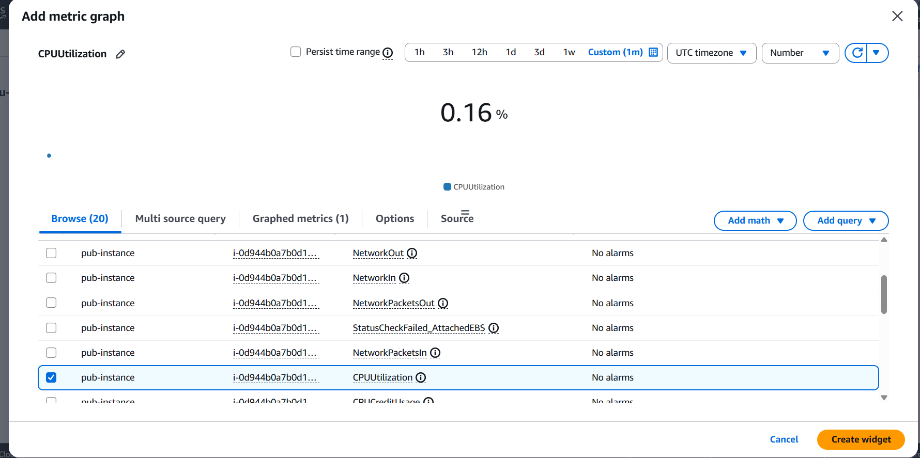
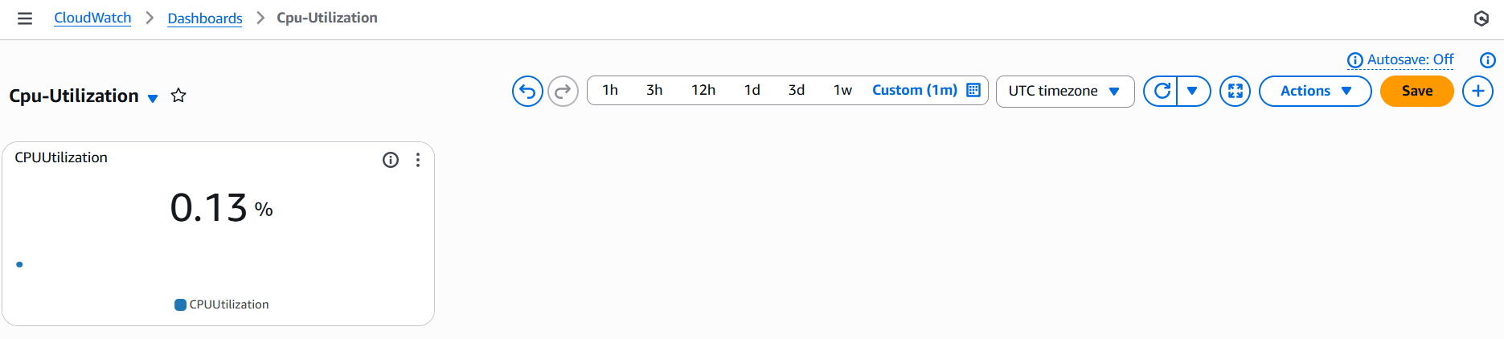

- Create one alarm to send alert to email if the cpu utilization is more than 70 percent.
Step 1:Goto CloudWatchcreate alarmselect metricsselect CPU Utilization of instanceIn condition select Greater than or Equal to 70.
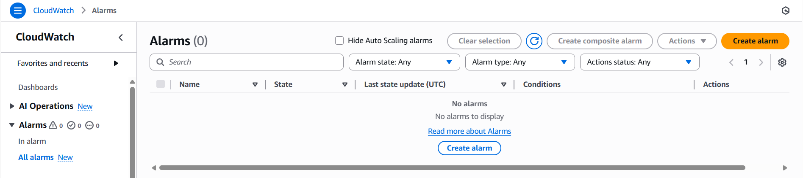
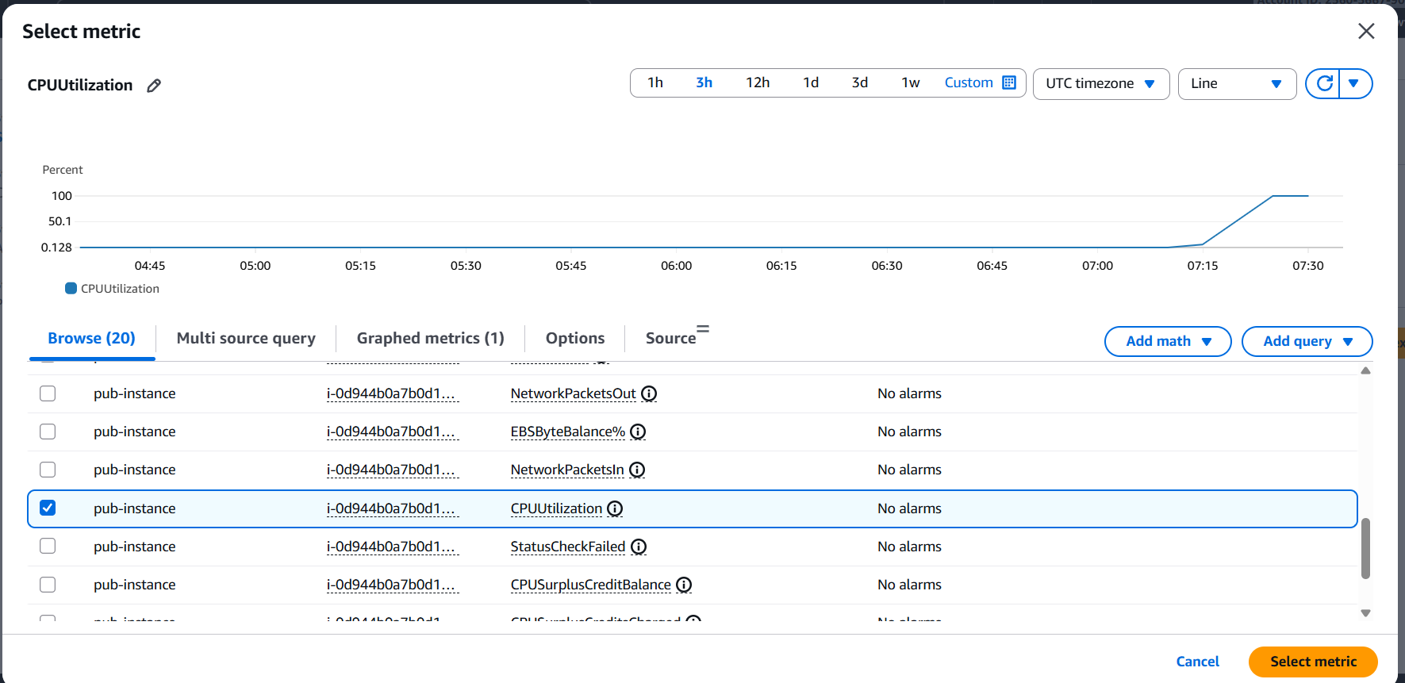
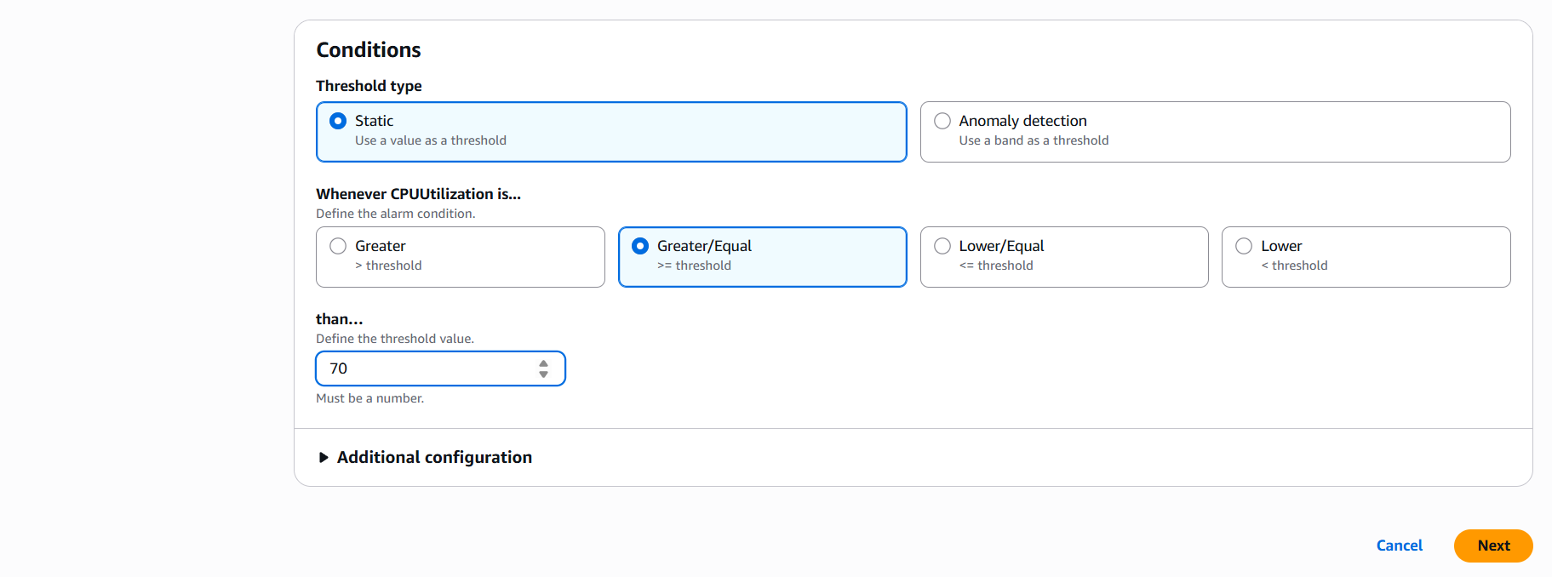

Step 2: In notification select In alarmSNSselect your SNSNext.
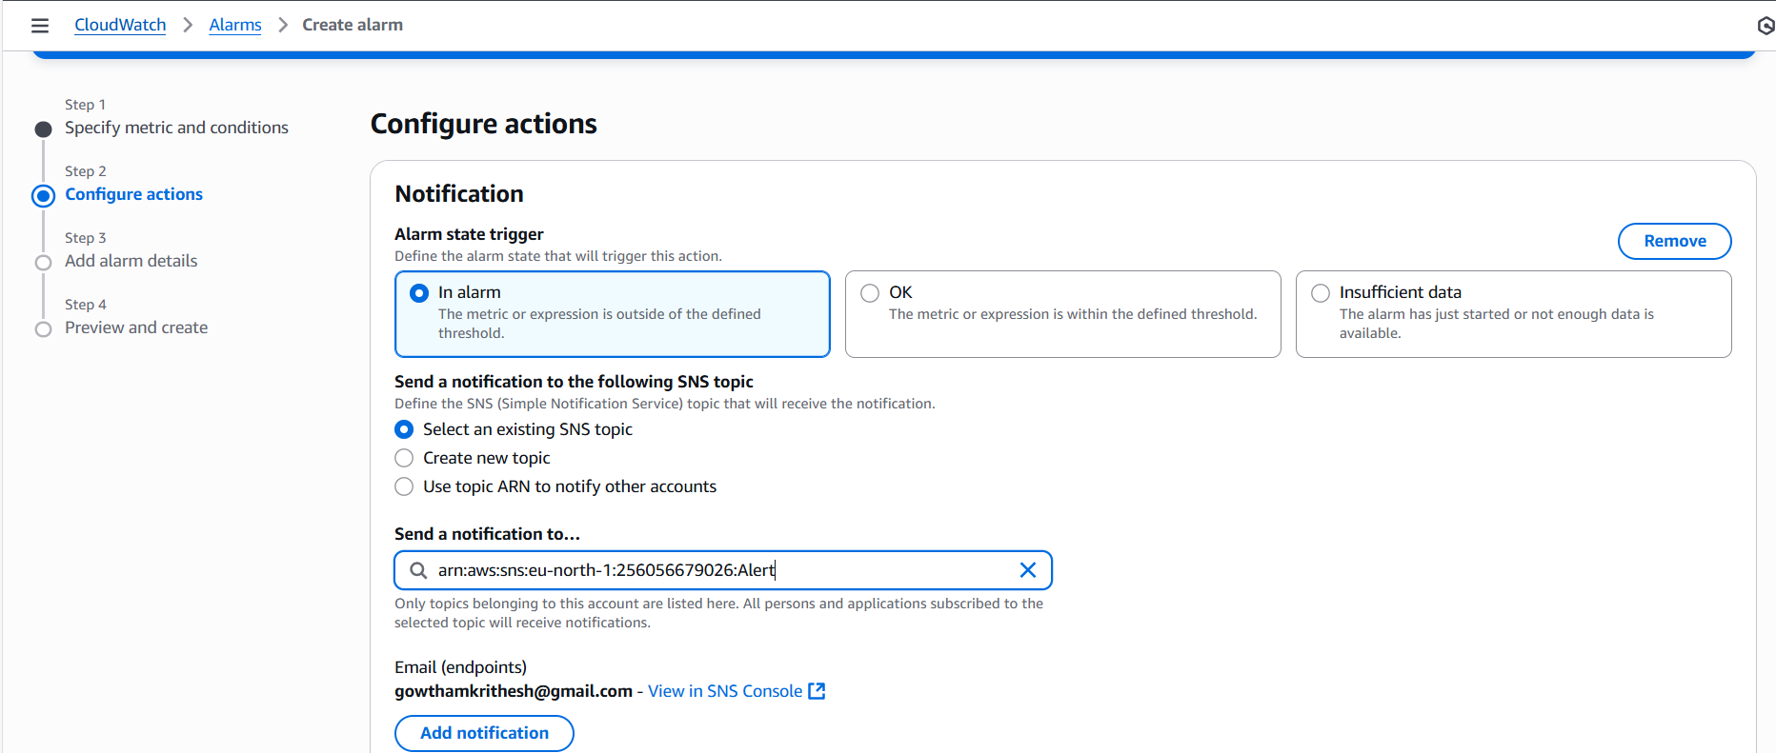
Step 3: Give alarm namePreview and create alarm.
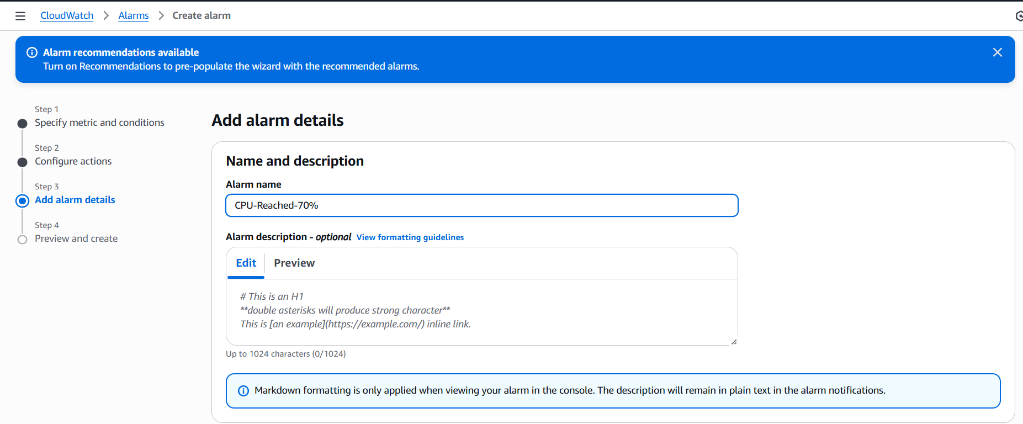
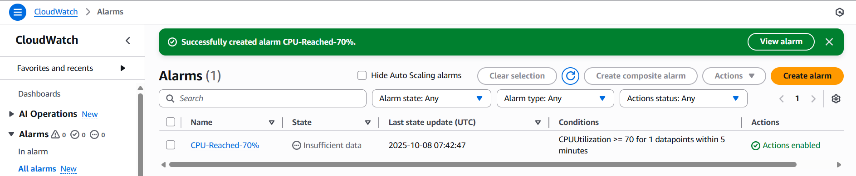
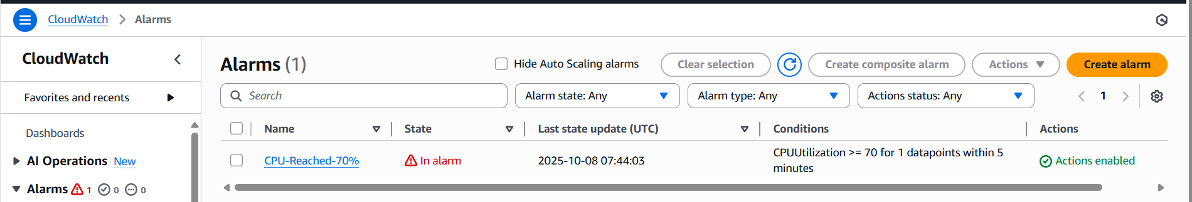

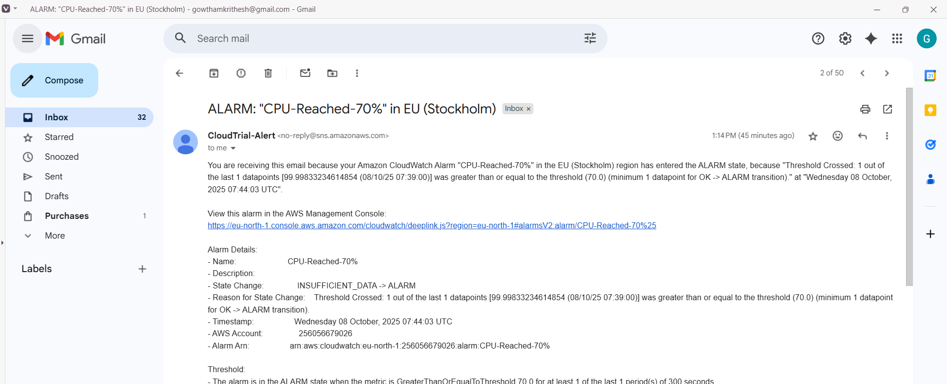
- Create Dashboard and monitor tomcat service whether it is running or not and send the alert.
Step 1: Launch and connect to EC2 instance and configure it.
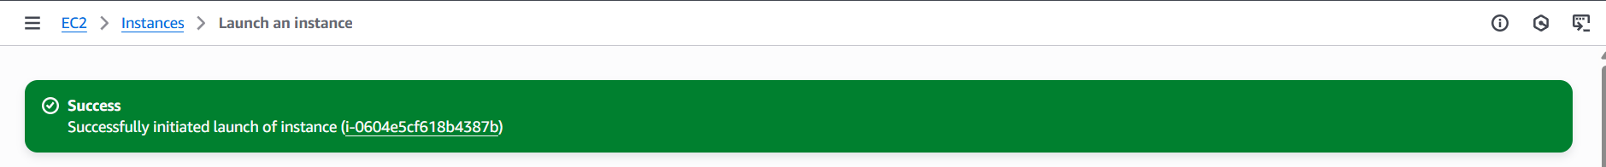
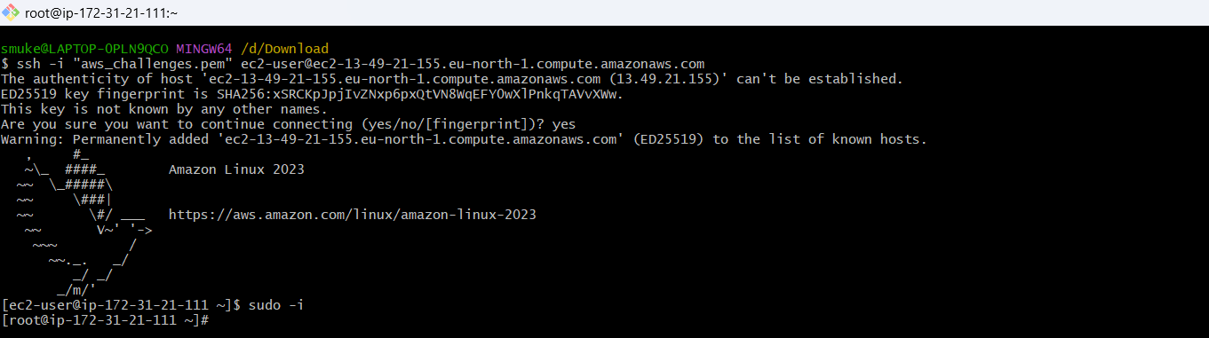
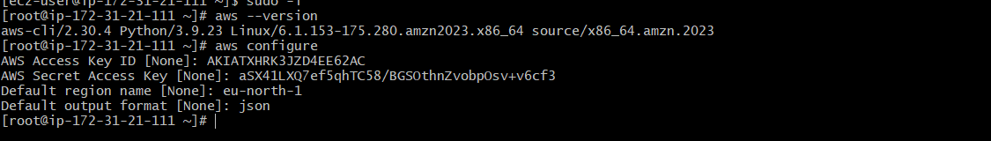
Step 2: Install Java, Apache tomcat and Run it.
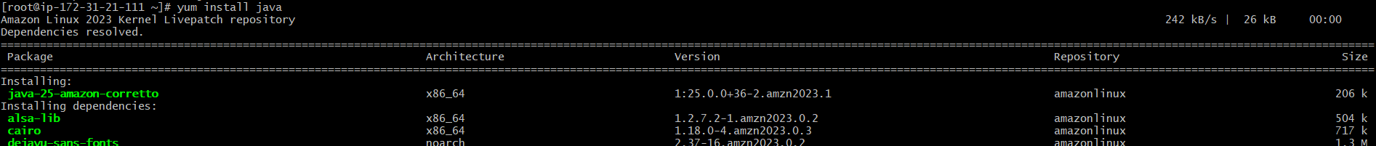
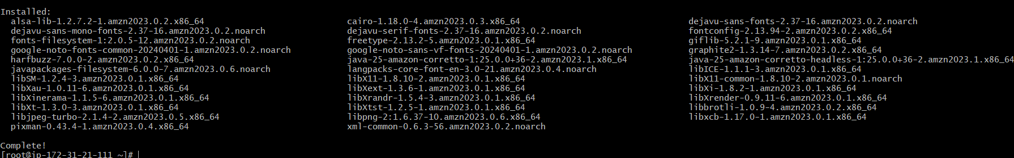

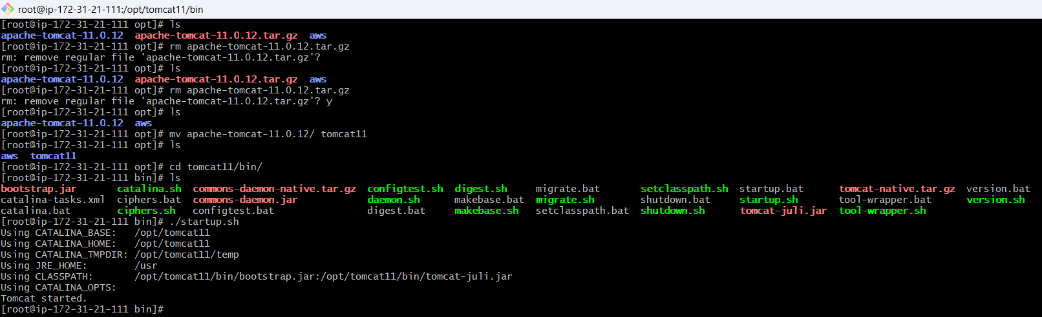
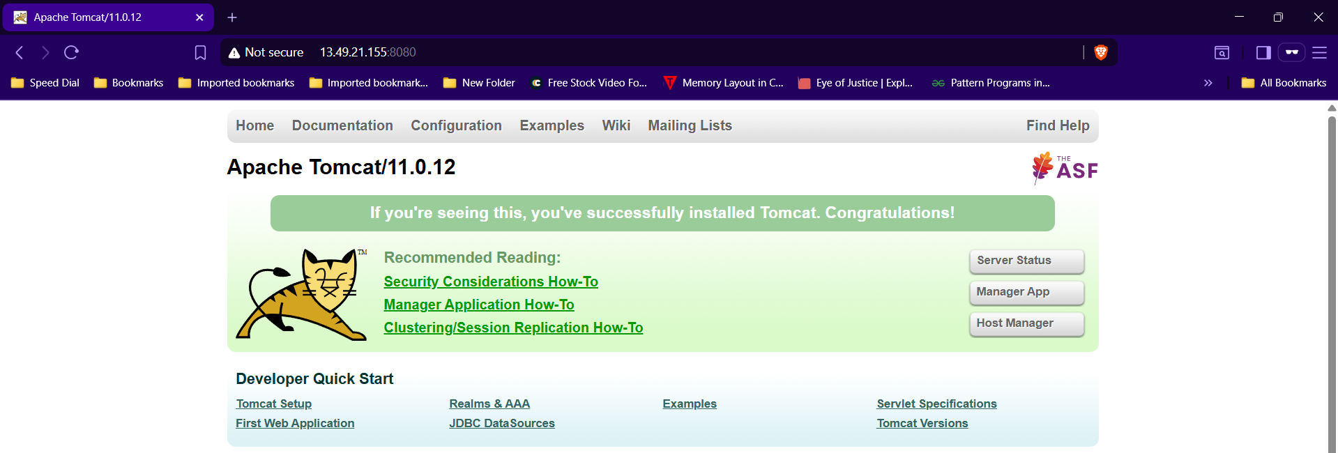
Step 3: Create a bash script to monitor tomcat and execute it.
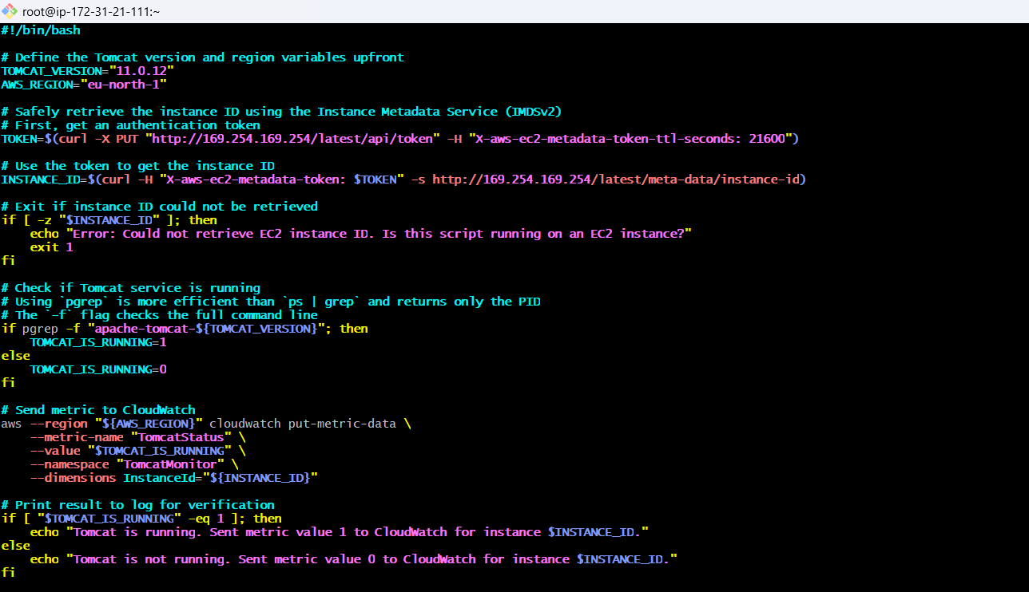

#!/bin/bash

# Define the Tomcat version and region variables upfront
TOMCAT_VERSION="11.0.12"
AWS_REGION="eu-north-1"

# Safely retrieve the instance ID using the Instance Metadata Service (IMDSv2)
# First, get an authentication token
TOKEN=$(curl -X PUT "http://169.254.169.254/latest/api/token" -H "X-aws-ec2-metadata-token-ttl-seconds: 21600")

# Use the token to get the instance ID
INSTANCE_ID=$(curl -H "X-aws-ec2-metadata-token: $TOKEN" -s http://169.254.169.254/latest/meta-data/instance-id)

# Exit if instance ID could not be retrieved
if [ -z "$INSTANCE_ID" ]; then
echo "Error: Could not retrieve EC2 instance ID. Is this script running on an EC2 instance?"
exit 1
fi

# Check if Tomcat service is running
# Using `pgrep` is more efficient than `ps | grep` and returns only the PID
# The `-f` flag checks the full command line
if pgrep -f "apache-tomcat-${TOMCAT_VERSION}"; then
TOMCAT_IS_RUNNING=1
else
TOMCAT_IS_RUNNING=0
fi

# Send metric to CloudWatch
aws --region "${AWS_REGION}" cloudwatch put-metric-data \
--metric-name "TomcatStatus" \
--value "$TOMCAT_IS_RUNNING" \
--namespace "TomcatMonitor" \
--dimensions InstanceId="${INSTANCE_ID}"

# Print result to log for verification
if [ "$TOMCAT_IS_RUNNING" -eq 1 ]; then
echo "Tomcat is running. Sent metric value 1 to CloudWatch for instance $INSTANCE_ID."
else
echo "Tomcat is not running. Sent metric value 0 to CloudWatch for instance $INSTANCE_ID."
Fi

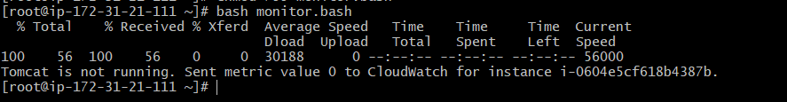
Step 4: Goto CloudWatch and create a Dashboard with tomcat metrics.
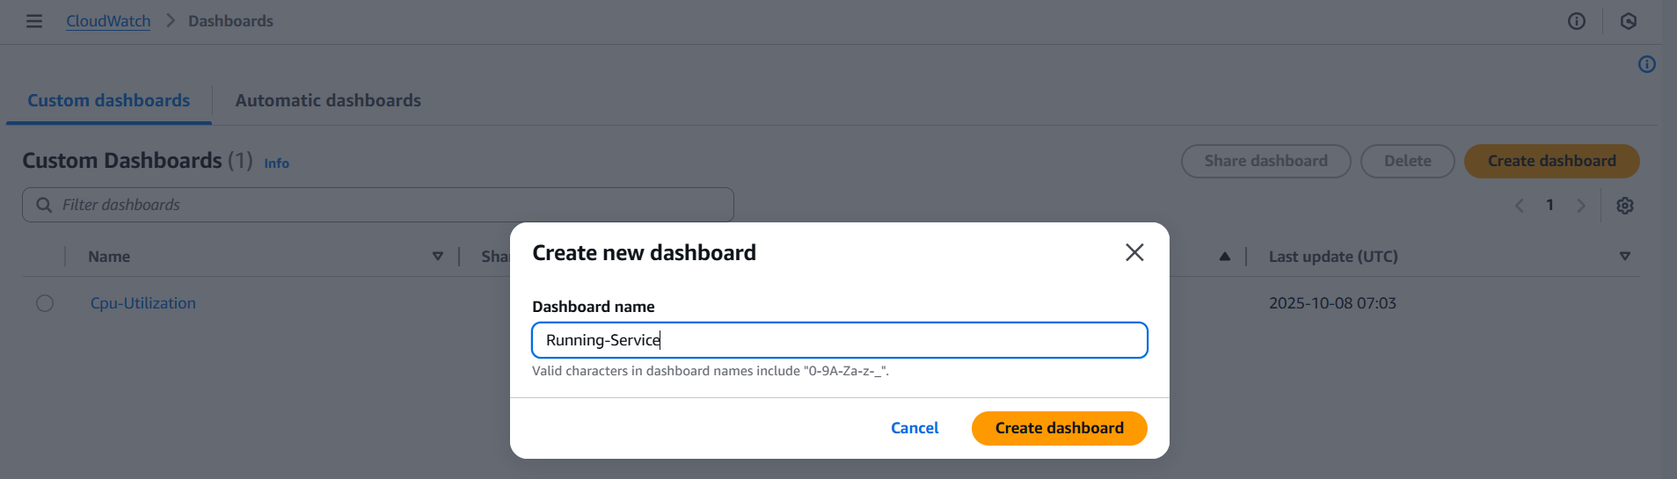
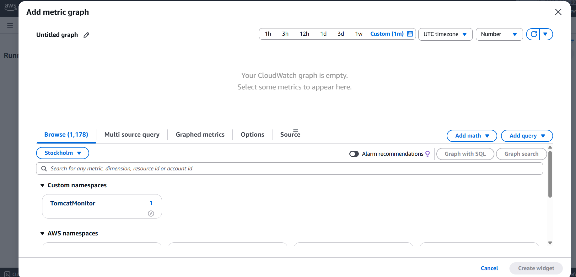
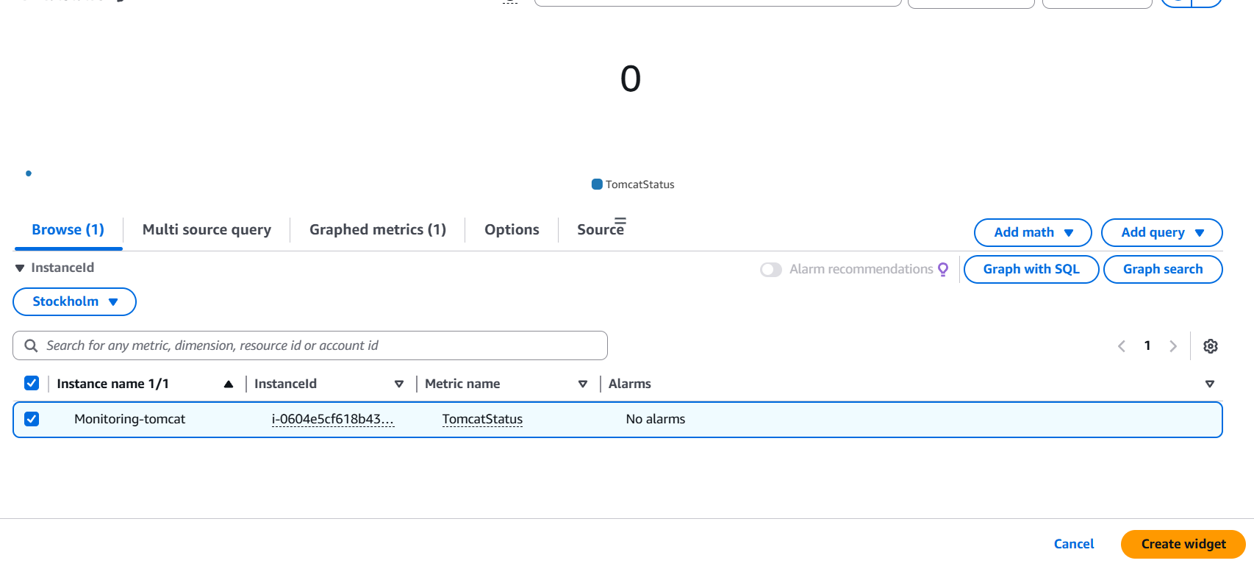
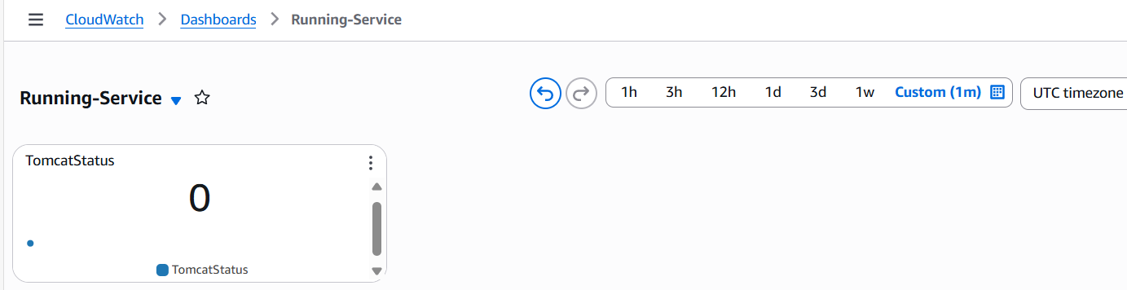

- Create Dashboard and monitor nginx service to send the alert if nginx is not running.
Step 1: Install start Nginx in EC2 instance and check the status.
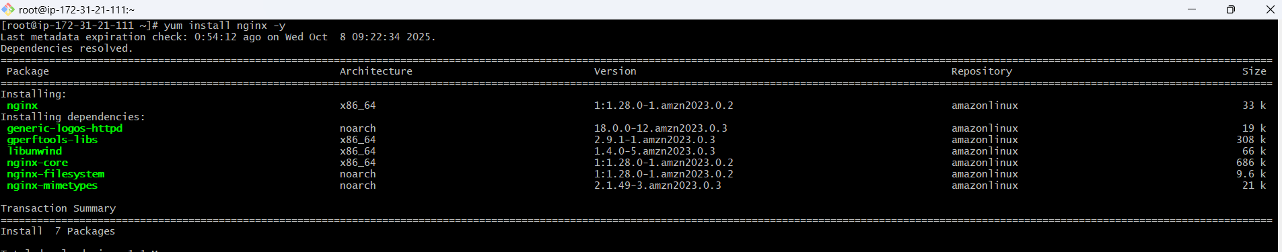
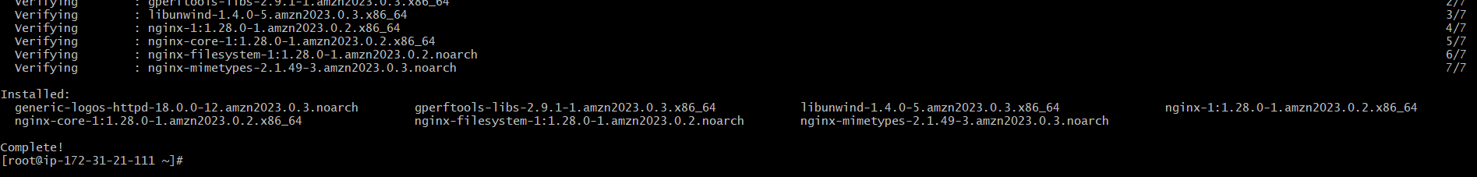
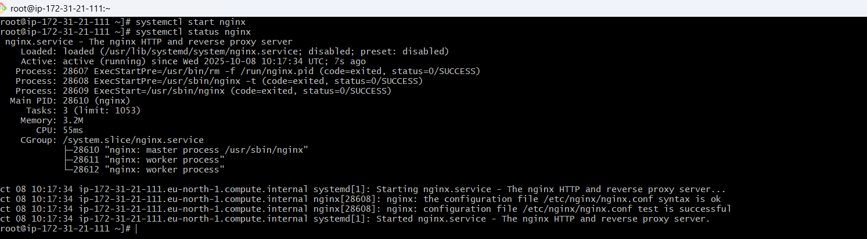
Step 2: Create and execute the bash script to send alert if nginx is not running.
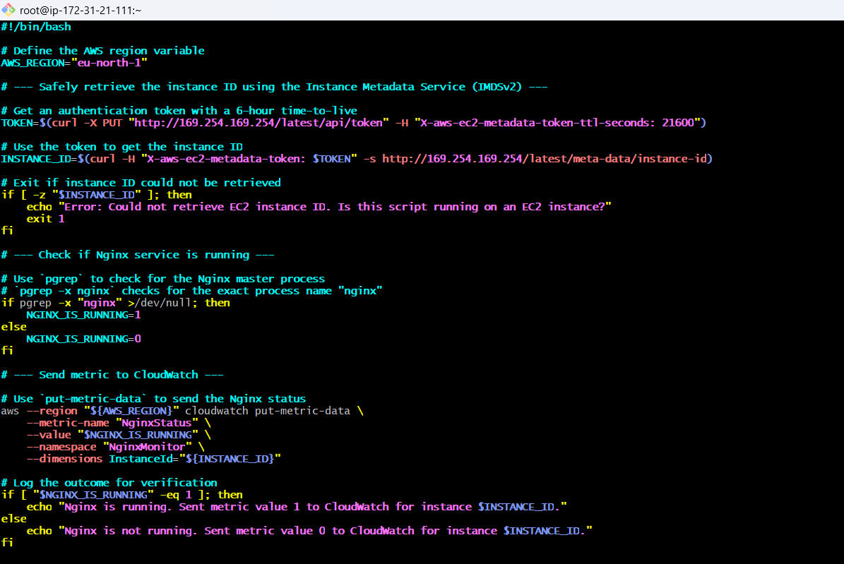
#!/bin/bash

# Define the AWS region variable
AWS_REGION="eu-north-1"

# --- Safely retrieve the instance ID using the Instance Metadata Service (IMDSv2) ---

# Get an authentication token with a 6-hour time-to-live
TOKEN=$(curl -X PUT "http://169.254.169.254/latest/api/token" -H "X-aws-ec2-metadata-token-ttl-seconds: 21600")

# Use the token to get the instance ID
INSTANCE_ID=$(curl -H "X-aws-ec2-metadata-token: $TOKEN" -s http://169.254.169.254/latest/meta-data/instance-id)

# Exit if instance ID could not be retrieved
if [ -z "$INSTANCE_ID" ]; then
echo "Error: Could not retrieve EC2 instance ID. Is this script running on an EC2 instance?"
exit 1
fi

# --- Check if Nginx service is running ---

# Use `pgrep` to check for the Nginx master process
# `pgrep -x nginx` checks for the exact process name "nginx"
if pgrep -x "nginx" >/dev/null; then
NGINX_IS_RUNNING=1
else
NGINX_IS_RUNNING=0
fi

# --- Send metric to CloudWatch ---

# Use `put-metric-data` to send the Nginx status
aws --region "${AWS_REGION}" cloudwatch put-metric-data \
--metric-name "NginxStatus" \
--value "$NGINX_IS_RUNNING" \
--namespace "NginxMonitor" \
--dimensions InstanceId="${INSTANCE_ID}"

# Log the outcome for verification
if [ "$NGINX_IS_RUNNING" -eq 1 ]; then
echo "Nginx is running. Sent metric value 1 to CloudWatch for instance $INSTANCE_ID."
else
echo "Nginx is not running. Sent metric value 0 to CloudWatch for instance $INSTANCE_ID."
Fi
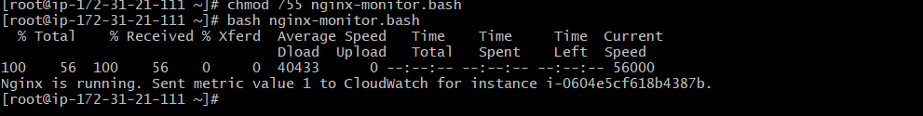
Step 3: Goto CloudWatch and create dashboard and alert.
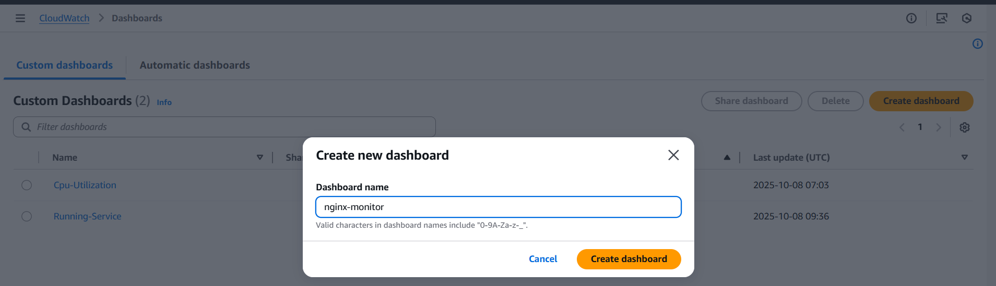
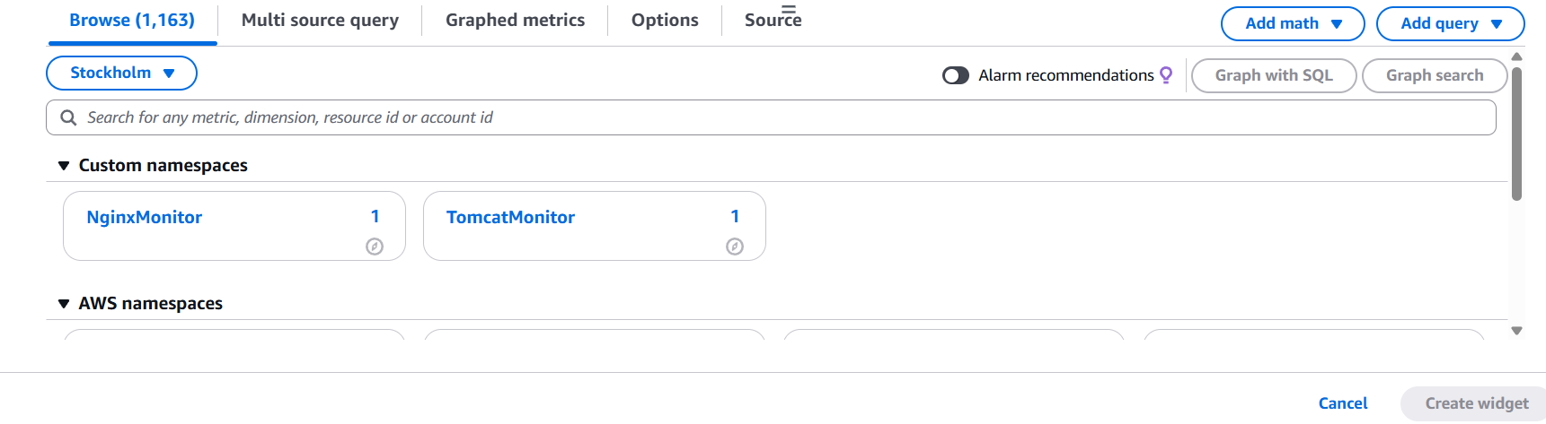


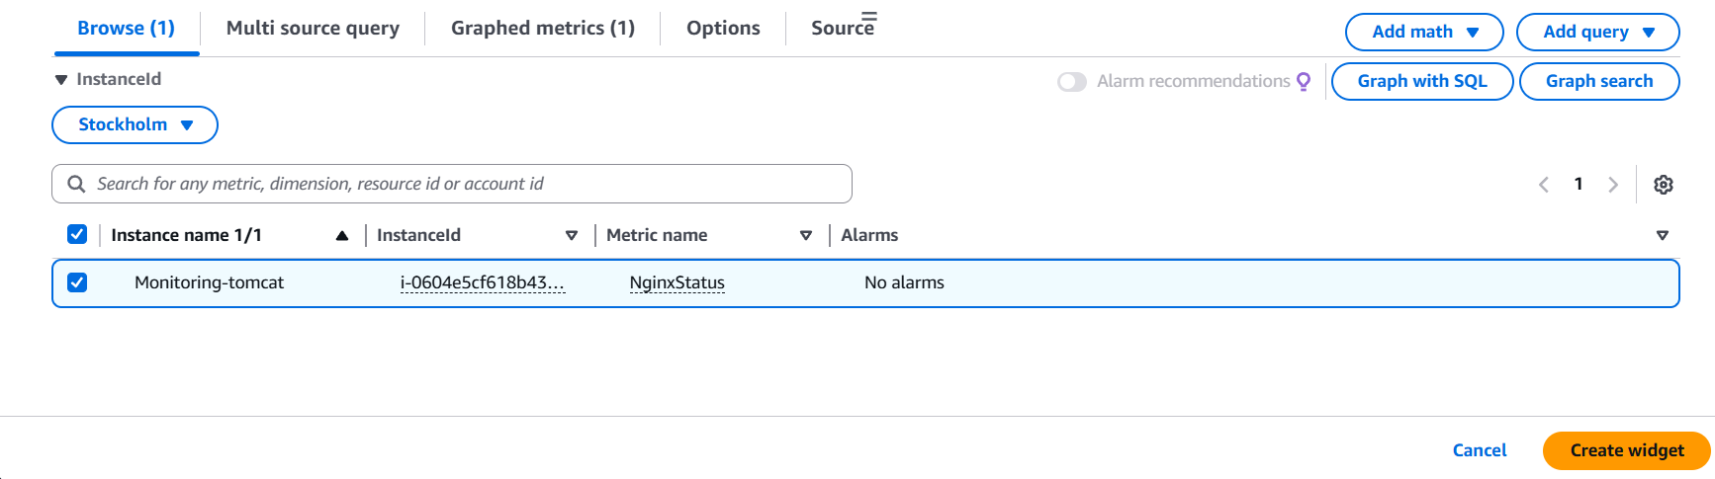
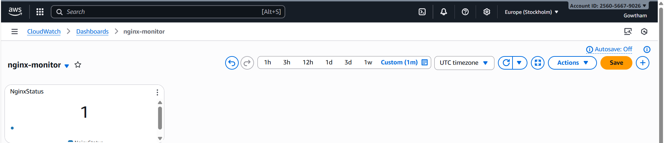
Step 4: Create a crontab to execute the script regularly.
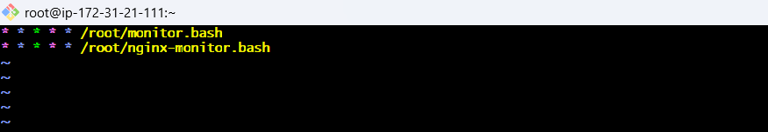
Step 5: In cloudWatch Goto Alarmcreate alarmselect metricsnginxSNS
